VLAN CONCEPTS

Q1. On a Cisco Packet Tracer switch, create two VLANs named 'Engineering' (VLAN 10) and 'Marketing' (VLAN 20) using the CLI commands.
Ans. I have created two vlan named engineering for vlan 10 and Marketing for vlan 20.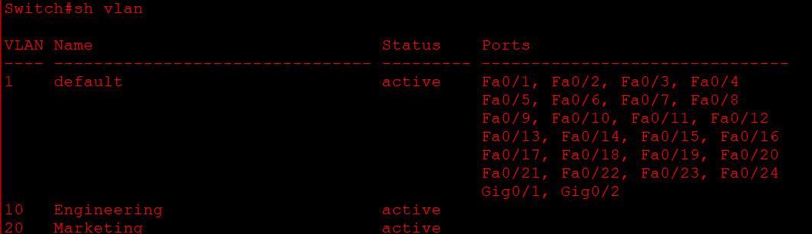
Q2. Assign ports FastEthernet0/1 and FastEthernet0/2 to VLAN 10, and ports FastEthernet0/3 and FastEthernet0/4 to VLAN 20 on your switch.
Ans. I have assigned VLAN 10 to Fa0/1-2 and VLAN 20 to Fa0/3-4.
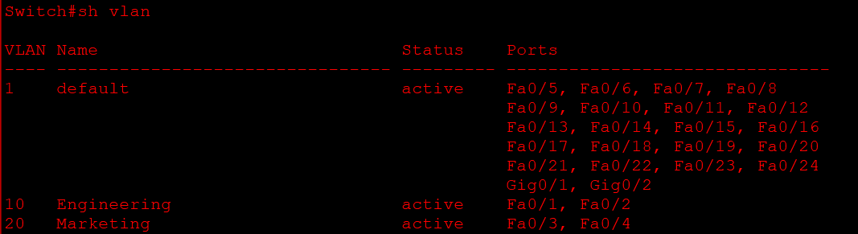
Q3. Write a short document (in a text file) listing the VLAN IDs, names, and the ports assigned to each VLAN from your configuration.
Ans. VLAN CONFIGURATION SUMMARY
Topology: Two Cisco switches (Switch 1 and Switch 2)
Switch 1
VLAN ID: 10 VLAN Name: VLAN10 (placeholder; actual name not confirmed)
Assigned Ports: FastEthernet0/2, FastEthernet0/3
VLAN ID: 20 VLAN Name: VLAN20 (placeholder; actual name not confirmed)
Assigned Ports: FastEthernet0/4, FastEthernet0/5
Switch 2
VLAN ID: 10 VLAN Name: VLAN10 (placeholder; actual name not confirmed)
Assigned Ports: FastEthernet0/2, FastEthernet0/3
VLAN ID: 20 VLAN Name: VLAN20 (placeholder; actual name not confirmed)
Assigned Ports: FastEthernet0/4, FastEthernet0/5
Verification Command: show vlan brief
Note: The VLAN IDs and port assignments reflect the previous configuration. Replace the placeholder VLAN names with the names shown in your switch output.
Q4. Explain, in your own words, two benefits of using VLANs in a college campus network that has separate labs for coding and networking.
Ans. Benefits of Using VLANs in a College Campus Network
1. Improved Security: VLANs separate the coding lab and networking lab into different networks. This prevents students from accessing devices in other labs without permission, improving network security.
2. Better Network Performance: VLANs reduce unnecessary network traffic by keeping broadcast traffic within each VLAN. This helps both labs work efficiently without affecting each other's network performance.
Conclusion: Using VLANs in a college campus improves security, network performance, and network management by keeping different labs logically separated.

